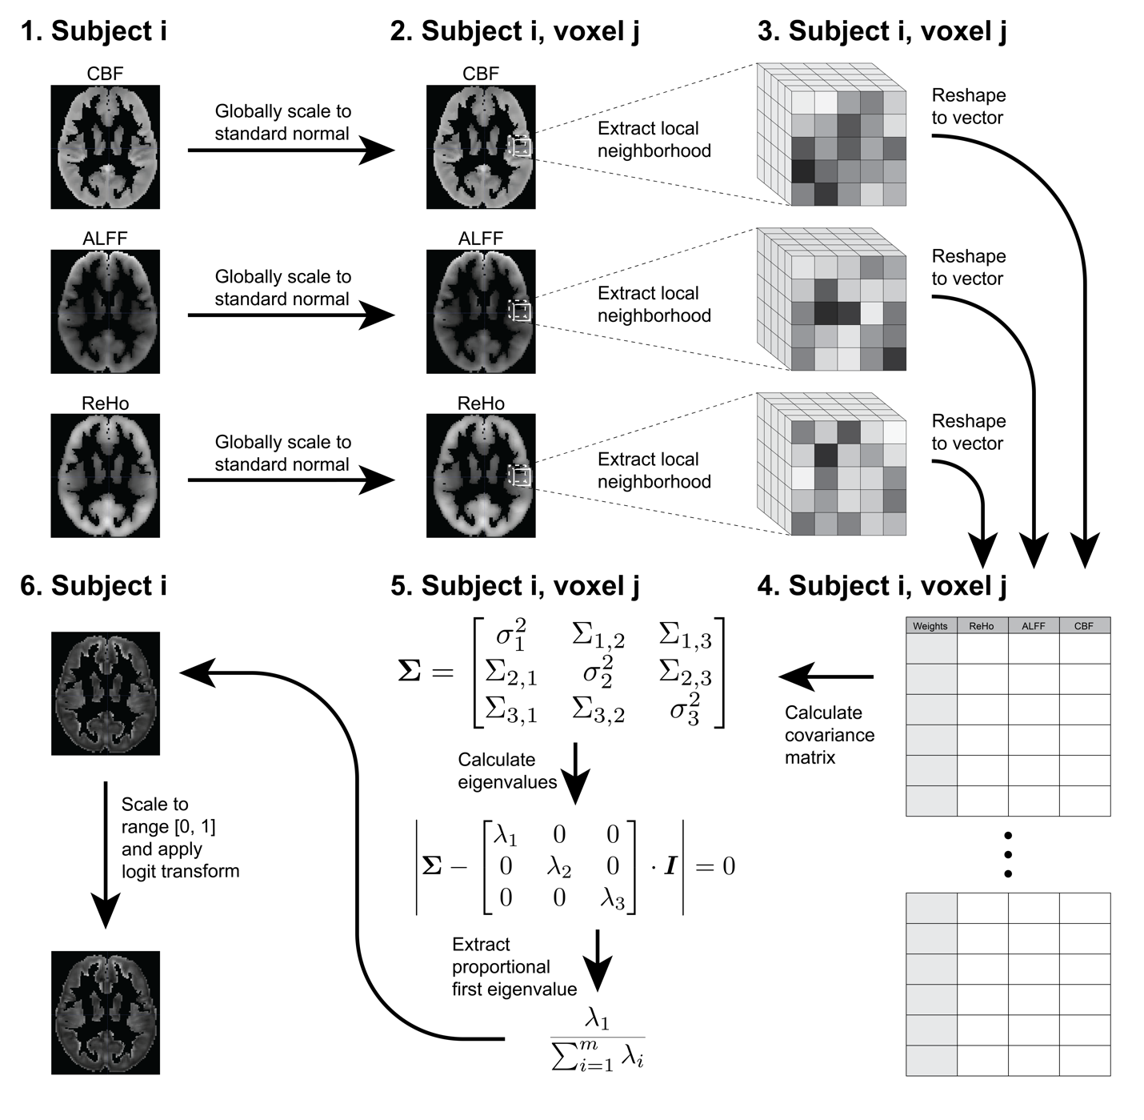

Figure 1: Step-by-step diagram of IMCo estimation pipeline.

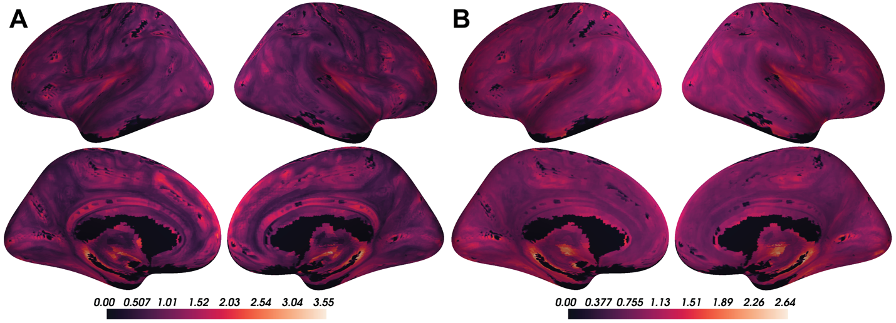

Figure 2: Coupling values are spatially heterogeneous across the cortical surface. A) Voxel-wise means across subjects of cortical coupling coefficients between CBF, ALFF, and ReHo. Larger values indicate stronger coupling. B) Voxel-wise variances across subjects of cortical coupling coefficients between CBF, ALFF, and ReHo.

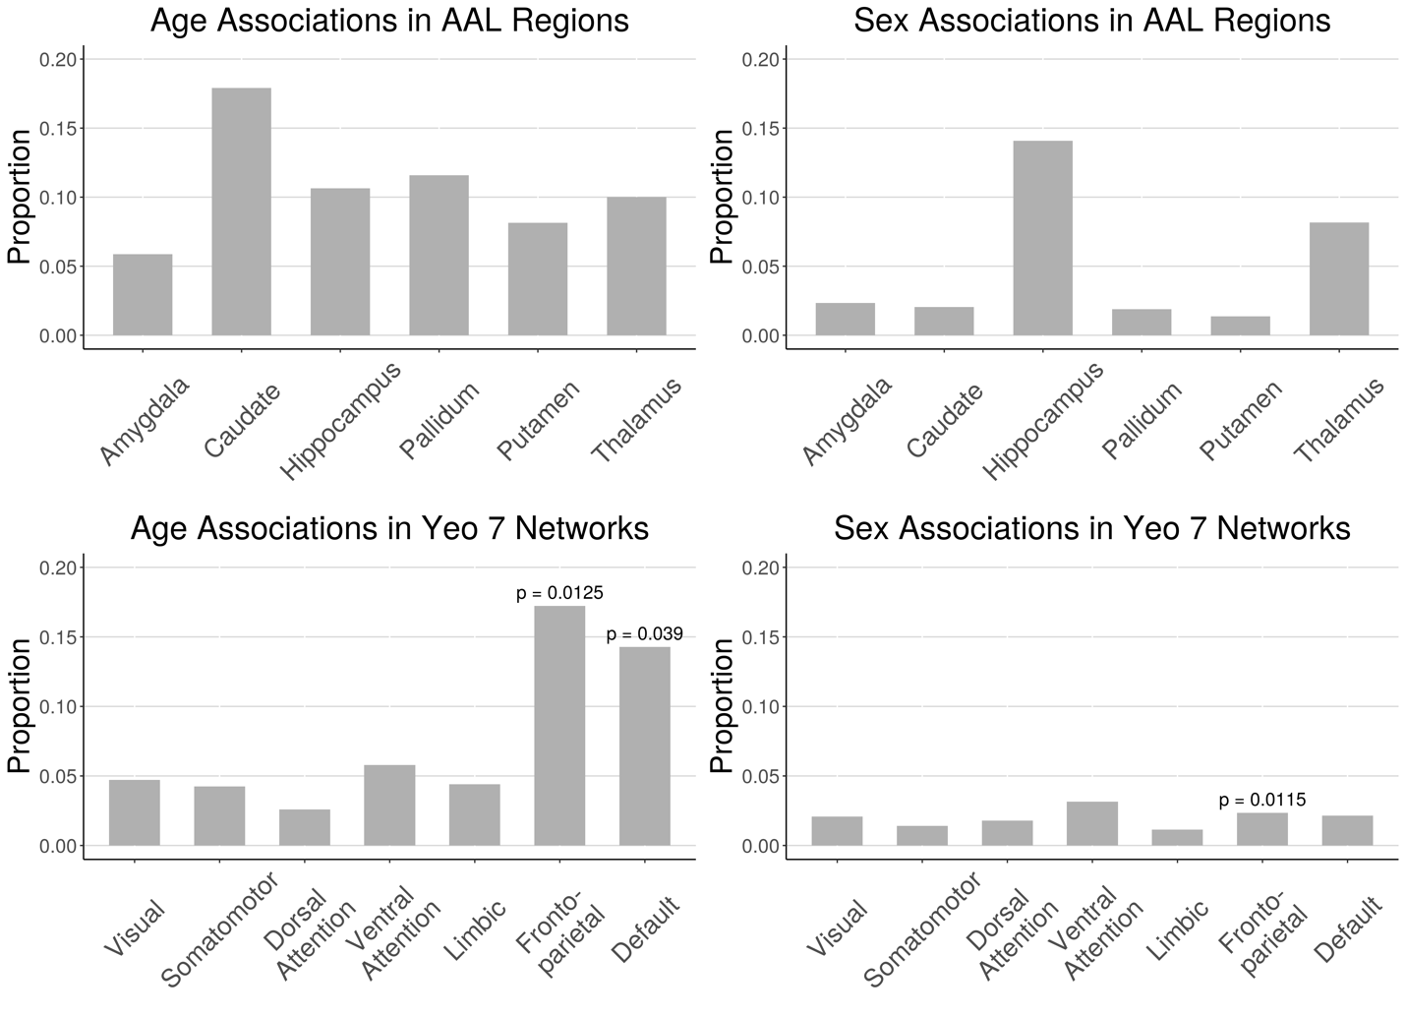

Figure 3: Proportion of voxels in AAL subcortical regions and Yeo 7 cortical networks that showed significant age and sex effects when race and in-scanner motion were corrected included as covariates (FDR corrected p < 0.05). Spin test was performed for Yeo 7 networks and significant p-values are reported (p < 0.05).

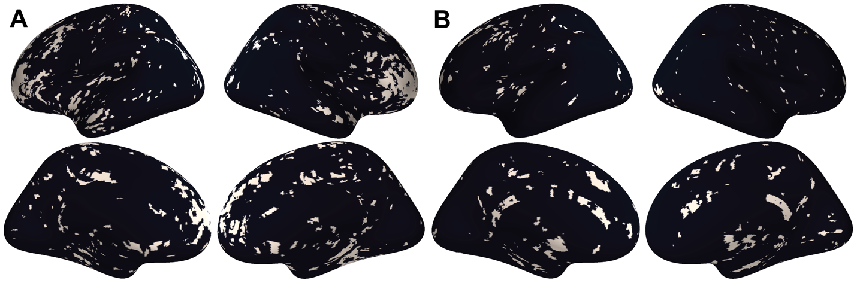

Figure 4: A) Thresholded maps of voxels with significant coupling associations with age after FDR correction at 0.05. B) Thresholded maps of voxels with significant coupling associations with sex after FDR correction at 0.05.

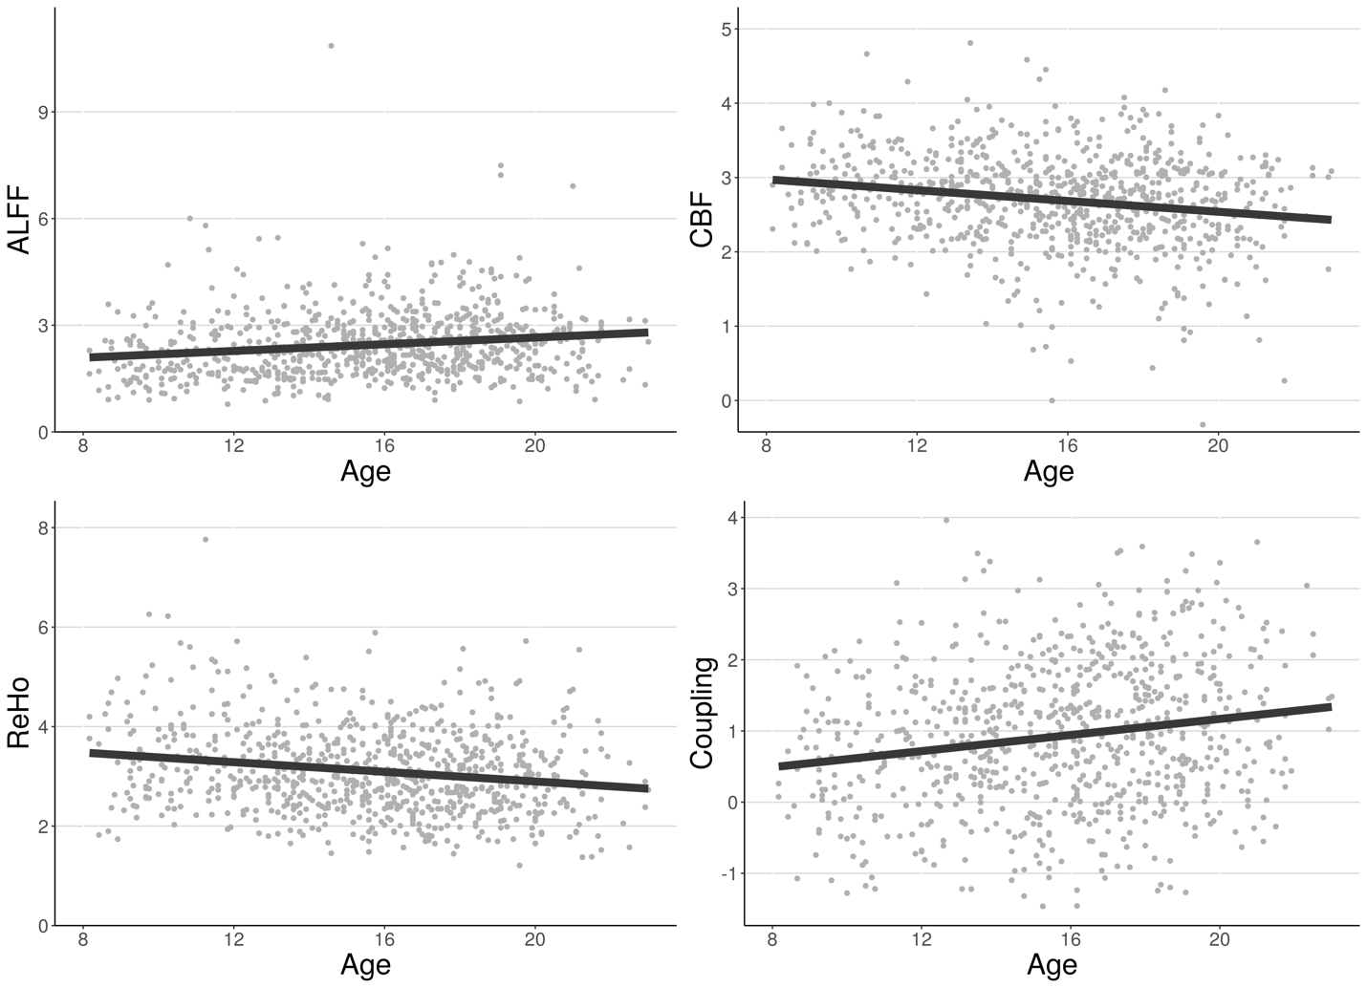

Figure 5: Example of associations between individual modalities and age as well as associations between coupling and age at a single voxel in the default network. Each point represents the value at that voxel in one subject. Best fit lines from univariate linear regression are shown.

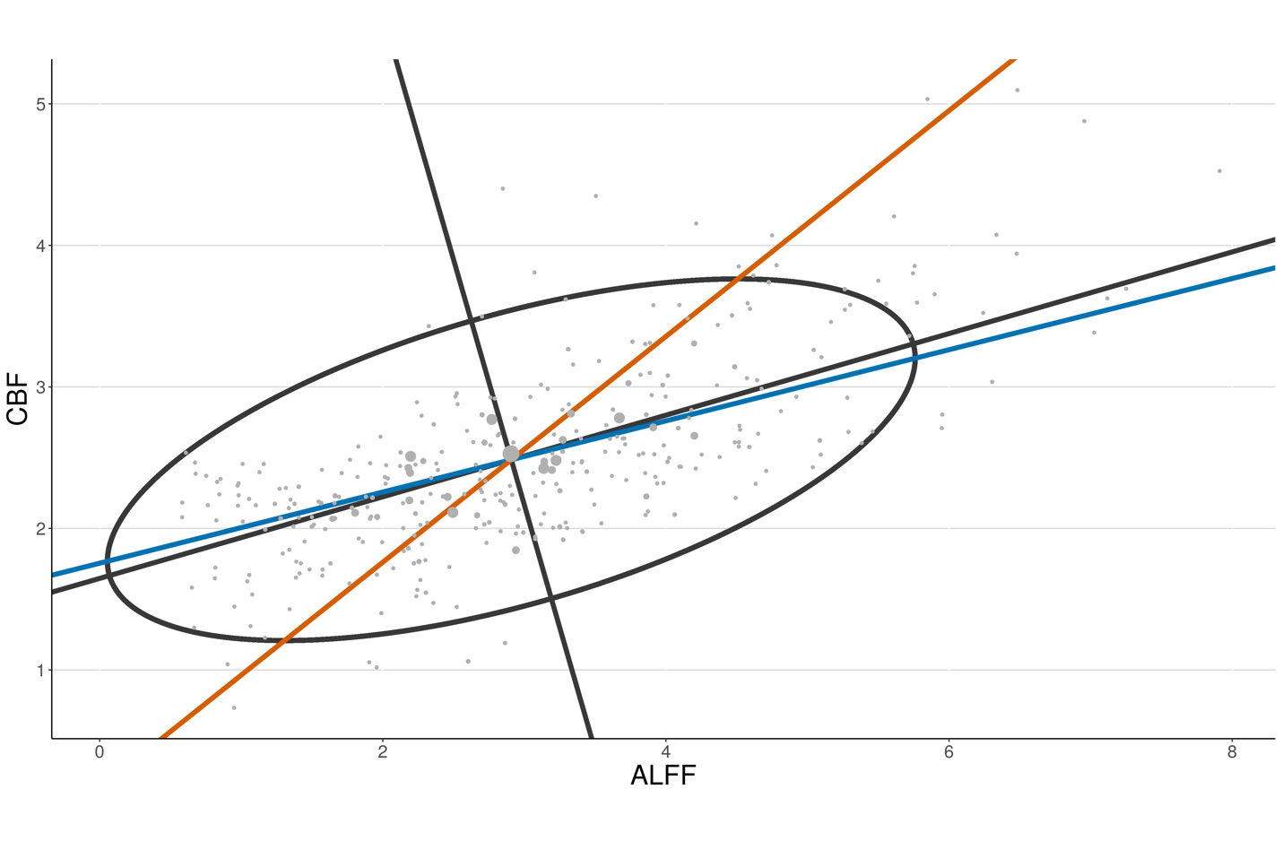

Figure 6: Two-modality example showing pIMCo results in comparison to WLR-based IMCo results. Blue line represents coupling value from WLR-based IMCo if ALFF is regressed on to CBF (slope = 0.25). Orange line represents coupling value from WLR-based IMCo if CBF is regressed on to ALFF (slope = 1.25). Black line and ellipse represent PCA results; no reference specification is needed (coupling value = 2.13).

# Supplementary Materials

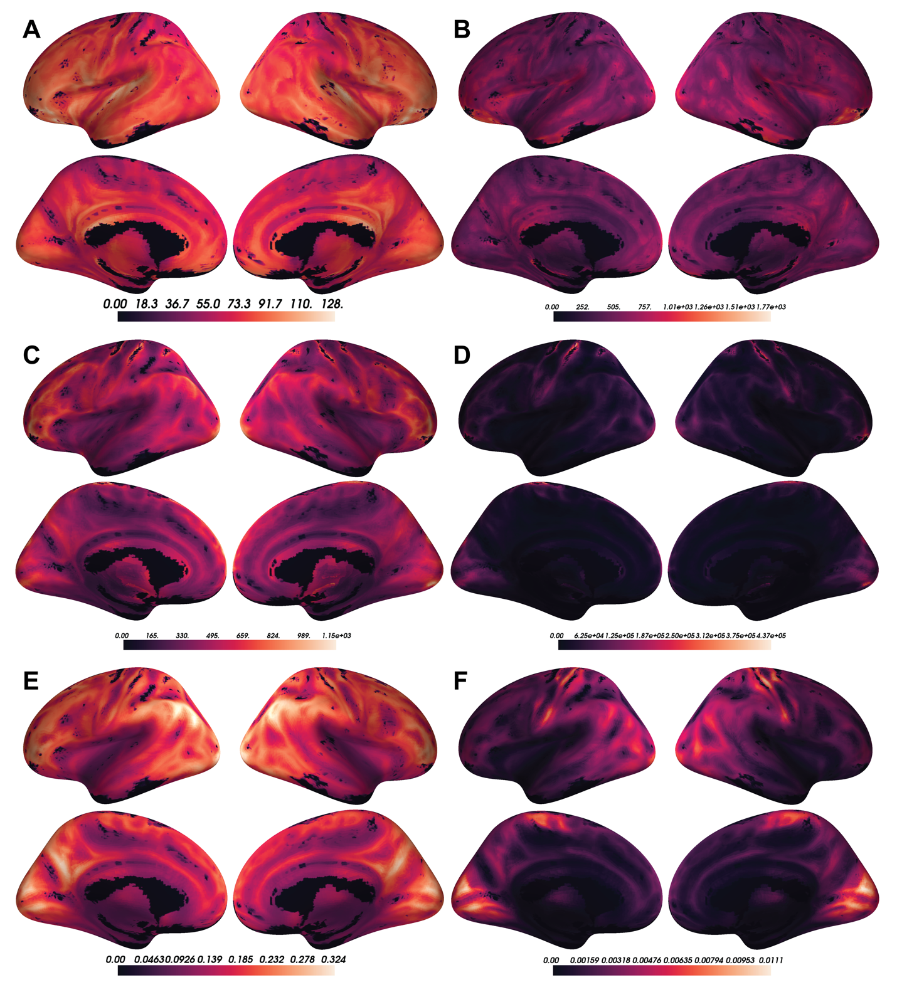

Figure S1: A) Voxel-wise means across subjects of cortical CBF. B) Voxel-wise variances across subjects of cortical CBF. C) Voxel-wise means across subjects of cortical ALFF. D) Voxel-wise variances across subjects of cortical ALFF. E) Voxel-wise means across subjects of cortical ReHo. F) Voxel-wise variances across subjects of cortical ReHo.